**ER Diagram:**

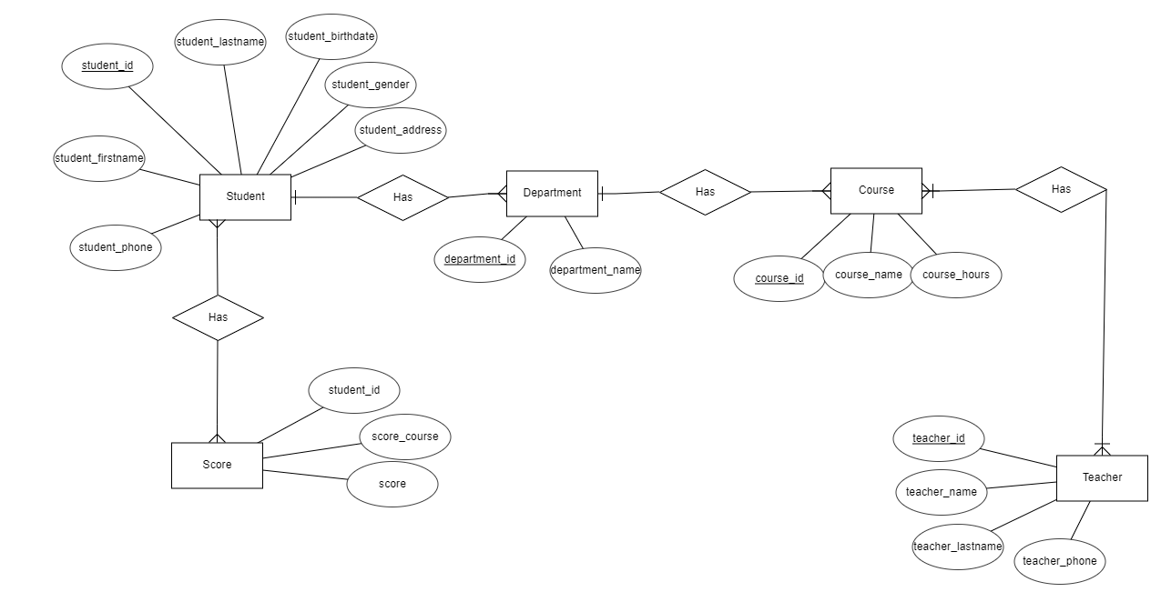

**Relational Schema:**

